LAMAR COUNTY SHERIFF’S OFFICE
125 BROWN AVENUE • PARIS, TEXAS 75460
PHONE: (903) 737-2400 FAX: (903) 783-0668

NOTICE OF ESTRAY

CASE NO: 23-01582 DATE: 08/31/2023

- PERSON REPORTING ESTRAY: Robert Pridemore
- DATE ESTRAY REPORTED TO SHERIFF: 08/31/2023
- LOCATION OF ESTRAY WHEN FOUND: 700 County Road 25310 Roxton Texas, 75477
- LOCATION OF ESTRAY WHILE IMPOUNDED: Cattlemen’s Livestock Commission,
1354 Clement Rd., Paris, TX 75460 (903)784-2238
- DESCRIPTION OF ESTRAY:
- KIND OF ANIMAL: Bull
- BREED: Longhorn
- COLOR: Red and white bull
- SEX: Male AGE: Yearling SIZE: Full
- BRAND, EARMARK, IDENTIFYING CHARACTERISTICS: NONE

Deputy R. Hill 1329____ 08/31/2023
LAMAR COUNTY, TX DATE
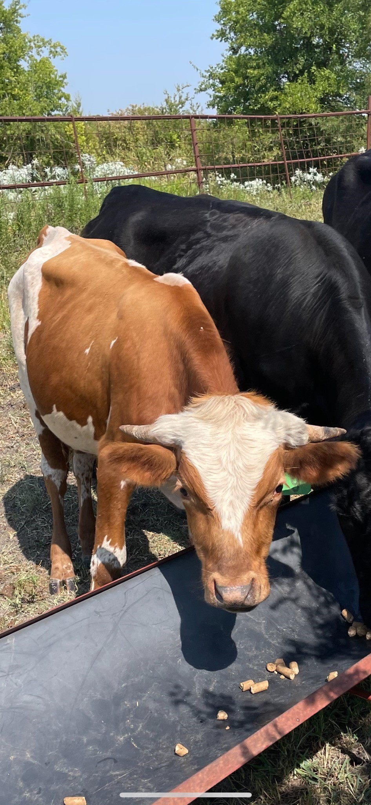
CASE NO:

LAMAR COUNTY SHERIFF’S OFFCIE
125 BROWN AVENUE • PARIS, TEXAS 75460
PHONE: (903) 737-2400 FAX: (903) 783-0668

NOTICE OF IMPOUNDMENT OF ESTRAY

CASE NO: 23-01582

- DATE REPORTED: 08/31/2023 IMPOUND DATE: 08/31/2023
- LOCATION WHILE IMPOUNDED: Cattlemen’s Livestock Commission, 1354 Clement Rd., Paris, TX 75460 (903)784-2238
- DESCRIPTION OF LIVESTOCK: Red and white bull
- HOW MANY IMPOUNDED: One
BRIEF NARRATIVE: On Thursday, August 31, 2023, one unknown red and white bull was impounded from the 700 block of County Road 25310 Roxton Texas, 75477. Lamar County cowboys transported the bull to Cattlemen’s Livestock Commission, 1354 Clement Rd. Paris Tx.
Deputies contacted Robert who claimed the bull showed up approximately 2 weeks ago and he was unable to locate an owner. Deputies attempted to locate an owner for the bull, but have been unsuccessful at this time.

Deputy R. Hill 1329
DEPUTY, LAMAR COUNTY BADGE NO.

