C26W

Prescribed by Secretary of State

Sections 4.004, 83.010, 85.004, 85.007, 172.1112, Election Code

07/2012

**NOTICE OF JOINT RUNOFF PRIMARY ELECTION**

AVISO DE ELECCIÓN PRIMARIA DE SEGUNDA VUELTA CONJUNTA

To the Registered Voters of the County of Navarro, Texas:

(A los votantes registrados del Condado de Navarro, Texas:)

Notice is hereby given that the polling places listed below will be open from 7:00 a.m. to 7:00 p.m., May 24, 2022, for voting in a runoff primary election both the Democratic and Republican Parties.

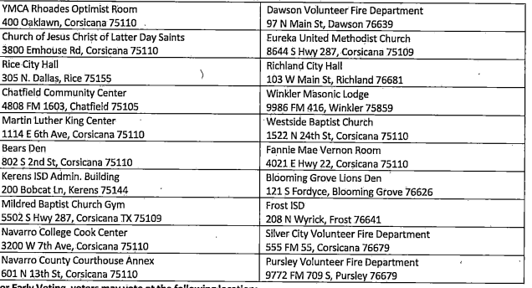

|  |  |  |
| --- | --- | --- |
|  |  |  |
|  |  |  |
|  |  |  |
|  |  |  |
|  |  |  |
|  |  |  |
|  |  |  |
|  |  |  |
|  |  |  |
|  |  |  |
|  |  |  |
|  |  |  |
|  |  |  |
|  |  |  |
|  |  |  |
|  |  |  |
|  |  |  |
|  |  |  |
|  |  |  |
|  |  |  |
|  |  |  |

**For early voting, a voter may vote at any of the locations listed below:**

***(Para Votación Adelantada, los votantes podrán votar en cualquiera de las ubicaciones nombradas abajo.)***

|  |  |
| --- | --- |
| Locations for Early Voting Polling Places  Include Name of Building and Address  *(Ubicación de las casillas electorales de votación adelantada)*  *(Incluir Nombre del Edificio y Dirección)* | Days and Hours of Operation  *Días y Horas Hábiles* |
| Navarro County Annex  601 N 13th St. Corsicana, TX 75110 | 5/16-5/20: 7:00 am to 7:00 pm |

Applications for ballot by mail shall be mailed or emailed to:

Las solicitudes para bloetas de votacion adelantada por correo deberan enviarse electrónico a:

**Allie Thomas:** Early Voting Clerk/Secretario de la Votacion Adelantado

**P.O. Box 1018:** Address Direccion

**Corsicana, TX 75151:**City/Ciddad Zip Code/Codigo Postal

[**athomas@navarrocounty.org**](mailto:athomas@navarrocounty.org)

Applications for ballots by mail must be received no later than the close of business on: May 13, 2018

Las solicitudes para boletas de votación adelantada por correo deberán recibirse para el fin de las horas de negocio el: 13 de Mayo, 2022

Issued this the 4th day of April, 2022.

Emitida este día 4 de Abril, 2022.