Public Notice to run in Silsbee Bee newspaper.
Notice should also be posted on County website, in County Courthouse, and other bulletin boards.

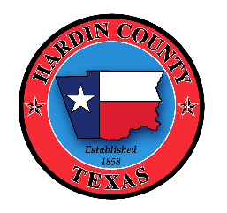

PUBLIC NOTICE
NOTICE OF OPPORTUNITY TO APPLY FOR HARDIN COUNTY HURRICANE HARVEY CDBG-DR ACQUISITION PROGRAM
Hardin County is conducting a voluntary acquisition project for homes damaged during Hurricane Harvey. The project will be administered locally and overseen by the Texas General Land Office (GLO) Community Development & Revitalization Program (CDR). The project is funded through a Community Development Block Grant for Disaster Recovery (CDBG-DR).
The application period will open on March 24th, 2021 and is scheduled to close on May 24th, 2021.
The Intake Beneficiary Application, along with application instructions and frequently-asked questions are available on the County website at http://www.co.hardin.tx.us/. Paper applications are also available at the County Courthouse at 300 W Monroe St, Kountze, TX 77625.
Completed applications can be submitted via email to cdbg4332acq@co.hardin.tx.us or via mail to the following address:
Hardin County
Attn: CDBG-DR Acquisition
300 W Monroe St
Kountze, TX 77625
Citizens with special needs or those who would like technical assistance may contact 512-202-1306.

