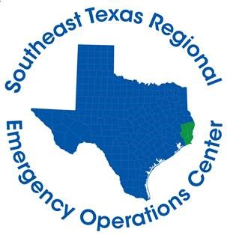

Hardin County Judge Wayne McDaniel
Jasper County Judge Mark Allen
Jefferson County Judge Jeff Branick
Newton County Judge Kenneth Weeks
Orange County Judge John Gothia
Tyler County Judge Jacques Blanchette

FOR IMMEDIATE RELEASE CONTACT: DAVILYN WALSTON
FRIDAY, APRIL 17, 2020 PUBLIC AFFAIRS OFFICER
CELL: (409) 553-9881
April 17th Daily Briefing

BEAUMONT, Texas – The Southeast Texas Regional Emergency Operations Center has summarized and consolidated all information related to COVID-19 activities in Hardin, Jasper, Jefferson, Newton, Orange, and Tyler counties at the following website:
https://covid-19-jeffco.hub.arcgis.com/
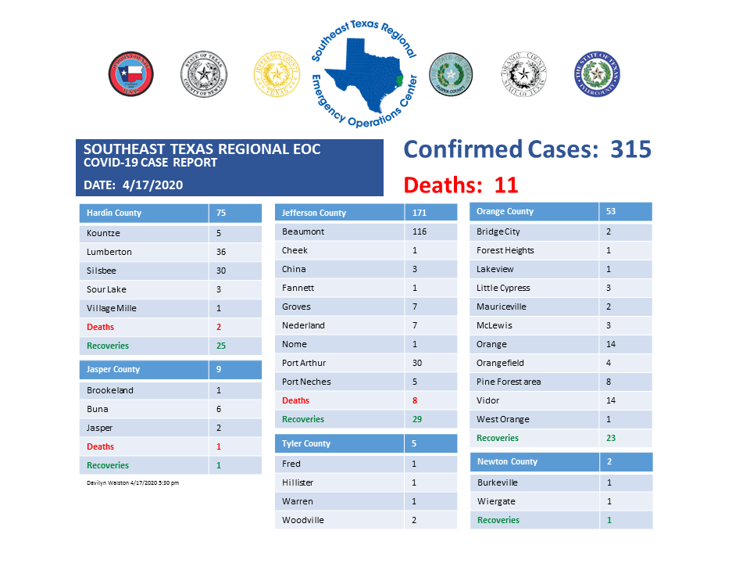
*These numbers are a compilation from several different health departments and may not be 100% accurate and are up-to-date as of the time of this posting.
Total calls received by Call Center – 4,287
- 145 calls received today
- 2,175 patients have been tested at the two test sites
If you are experiencing symptoms such as cough, shortness of breath, or fever, please call 409-550-2536 for an appointment to be tested for COVID-19. The Call Center is closed each night from 8:00 pm until 8:00 am. If you call during this time, you will be directed to leave a message with your name and phone number. Someone will call you the next morning to schedule an appointment for testing. If you feel like it’s an emergency, please hang up and call 911 immediately. If you would like general information on the Coronavirus, please call 211 and select Option 6 when prompted.

