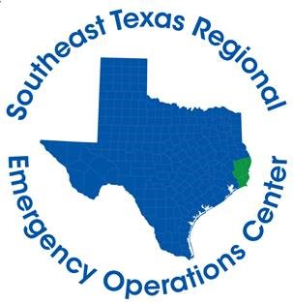
Hardin County Judge Wayne McDaniel
Jasper County Judge Mark Allen
Jefferson County Judge Jeff Branick
Newton County Judge Kenneth Weeks
Orange County Judge John Gothia
Tyler County Judge Jacques Blanchette

FOR IMMEDIATE RELEASE CONTACT: DAVILYN WALSTON
MONDAY, APRIL 6, 2020 PUBLIC AFFAIRS OFFICER
CELL: (409) 553-9881
April 6th Daily Briefing

BEAUMONT, Texas – The following information from the Southeast Texas Regional Emergency Operations Center summarizes activities and developments related to COVID-19 in Hardin, Jasper, Jefferson, Newton, Orange, and Tyler counties:
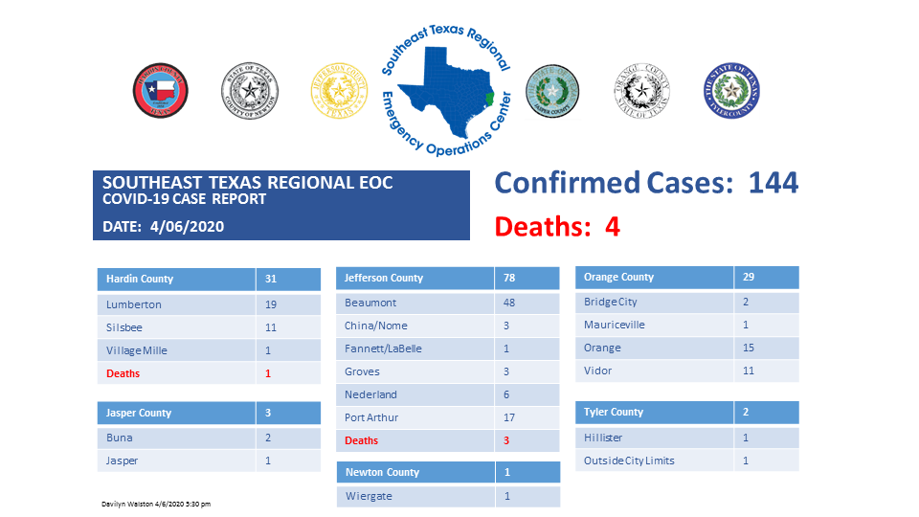
*These numbers are a compilation from several different health departments and may not be 100% accurate and are up-to-date as of the time of this posting.
Total calls received by Call Center – 2,739
- 144 calls received today
- 650 have been tested at the site in Jefferson County
- 233 have been tested at the site in Hardin County
If you are experiencing symptoms (fever, dry cough, shortness of breath) or you believe you have been exposed to an infected individual, you can call 409-550-2536 to be evaluated for testing. The Call Center is open 24-hours, seven days a week.
If you are looking for information about COVID-19, please do not call the Call Center. You can call 211 option 6 or visit SETINFO.ORG.

