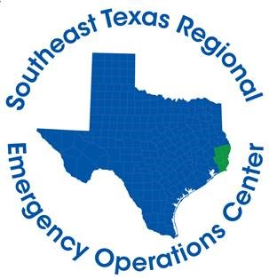

Hardin County Judge Wayne McDaniel
Jasper County Judge Mark Allen
Jefferson County Judge Jeff Branick
Newton County Judge Kenneth Weeks
Orange County Judge John Gothia
Tyler County Judge Jacques Blanchette

FOR IMMEDIATE RELEASE CONTACT: DAVILYN WALSTON
SATURDAY, APRIL 4, 2020 PUBLIC AFFAIRS OFFICER
CELL: (409) 553-9881
April 4th Daily Briefing

BEAUMONT, Texas – The following information from the Southeast Texas Regional Emergency Operations Center summarizes activities and developments related to COVID-19 in Hardin, Jasper, Jefferson, Newton, Orange, and Tyler counties:
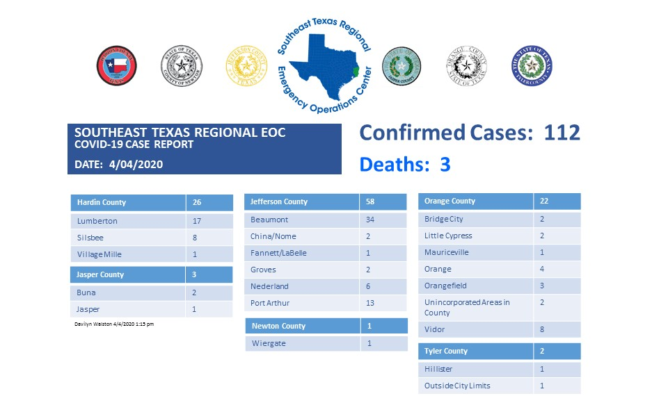
*These numbers are a compilation from several different health departments and may not be 100% accurate and are up-to-date as of the time of this posting.
If you are experiencing symptoms (fever, dry cough, shortness of breath) or you believe you have been exposed to an infected individual, you can call 409-550-2536 to be evaluated for testing. The Call Center is open 24-hours, seven days a week.

