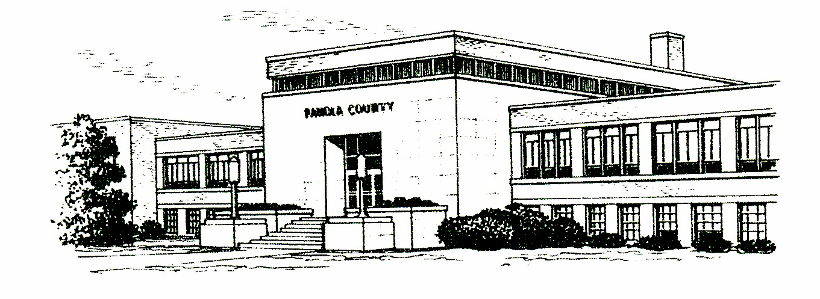

OCCUPATIONAL DRIVER’S LICENSE HELP
FOR PANOLA COUNTY JUSTICE COURTS

How can an Occupational Driver’s License help you?
Has your driver’s license been suspended, revoked or denied? As long as it is NOT for medical reasons or delinquent child support—you may qualify to have an ODL granted to you.

What does an Occupational Driver’s License authorize?
Allows you to operate a NON-commercial vehicle for work, school-related activities, performing household duties, and/or to search for employment if you are currently unemployed at the time of the filing of your petition for the Occupational License.

Check for Fees and Eligibility
You can go online to www.texas.gov/LicenseEligibility --please be sure to print off any confirmation of payment of fees or confirmation of none due. You can also check your driving record, one will be required to file with the court anyway. Either have one mailed to you for $10 or print one from online for more because of the convenience of same day printing. Go to www.texas.gov and you need the AR certified version for the Court.

How or where do you file to obtain ODL?
File your petition with the Court that suspended your driver’s license privileges; or to the Court of original jurisdiction where the offense(s) occurred. Or, in the appropriate Court of where you reside. Not all ODL filings can be processed with JP Courts. Alcohol and Drug-related suspensions normally must be filed with the District or County Courts.

Currently the filing fees with either Panola County JP Court is $46.00 which can be paid by Cash, Money Order, or by Credit Card—due at the time of filing your Petition and paperwork. There will be fees for copies and the fee to obtain your actual license from Austin. These will be explained at filing and completion of the case.

Once ODL granted
You must have in your possession the actual photo copy of the Occupational Driver’s License plus the Court’s Order Granting the Occupational License. You will be required to have both of these in your possession in order for your driving privilege to be legal. Failure to do so is a Class B Misdemeanor, and you are subject to arrest.

Page 1 of 2
Waiting Periods/Denial of Issuance
If you are granted the ODL by the Court, generally it is Effective Immediately. However, there will be times that a mandatory waiting period will be ordered. There will also be times that the State of Texas will require waiting periods. The Court or the State could DENY the issuance for this time frame or simply allow it to be a waiting period before going into effect.

- An alcohol or drug-related offense that results in suspension and there is a 90-day waiting period.
- An Intoxication-related conviction results in suspension and there is a 180-day waiting period.
- If you have two or more Administrative license revocations on your driving record—and there is a mandatory one-year waiting period.
- You request to operate a commercial motor vehicle—cannot be granted until the suspension, revocation, cancellation, or denial is lifted.
- You have NOT paid all of your reinstatement fees in full to Austin.
- Your driver’s license has been expired for 2 (two) years or more during the time frame of becoming suspended, revoked, canceled, or denied. If you are expired longer than 2 years, the State requires you to take the Class C written and driving portion of the tests and pass both before they will allow your operating privileges to be legal (whether by ODL or valid License).

Failure to submit the required documentation within a certain timeframe or by the hearing date, if one is required, may lead to a Denial of your request for Occupational Driver’s License. Currently, the State of Texas does not have an appeal process for ODL cases. You do have other options.

ANY FORMS, MOST QUESTIONS, ETC CAN BE FOUND ONLINE AT www.TexasLawHelp.org
WE DO MAKE THE FORMS FOR FILING AVAILABLE
AT NO COST IN OUR OFFICE.
If you need legal advice, and cannot afford an attorney,
you can contact Legal Aid at 903-758-9123.
An attorney is not required to represent you for any portion of the Occupational Driver’s License process in Justice Court.

Judge Larry Fields, pct 1 Judge Toni Hughes, pct 2
110 S. Sycamore rm 105 110 S. Sycamore Rm 212
Carthage, TX 75633 Carthage, TX 75633
903-693-0375 903-693-0377
Fax: 903-694-2674 Fax: 903-693-4708

Page 2 of 2

