County of Goliad
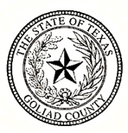

MIKE BENNETT
COUNTY JUDGE
P.O. Box 677 (361) 645-3337
Goliad, Texas 77963 Fax (361) 645-3474
mbennett@goliadcountytx.gov

Notice is hereby given that a Public Hearing on the FY2032 Proposed Goliad County Budget will be held August 8, 2022, at 6:00 p.m., in the second-floor courtroom of the Goliad County Courthouse, 127 N. Courthouse Sq., Goliad, Texas.

Signed and dated on the 29th day of July, 2022

Mike Bennett, County Judge

Posted at _____ a.m/p.m., on the 29th day of July, 2022, on the bulletin board at the door of the County Courthouse.

