AW6-2

Prescribed by Secretary of State Section 127.097(c), Texas Election Code 3/07

**1ST TEST OF L&A AUTOMATED TABULATING EQUIPMENT**

I, **RENEE' MCBAY,** the **ELECTION ADMINISTRATOR** of Freestone County does hereby acknowledge that the L & A test of the automated tabulating equipment to be used to count the ballots for the

**GENERAL ELECTION** to be held on **NOVEMBER 5, 2024** will be conducted with a pre-audited group of ballots marked and recorded with a predetermined number of valid votes for each candidate and on each measure. The test will also include ballots which had votes cast in excess of the number allowed by law in certain races, in order to determine the ability of the automatic tabulating equipment to reject such votes and ballots with other improper votes.

This test will be conducted on **OCTOBER 10, 2024 AT 3:00 PM.** And will conclude at

FILED FOR RECORD

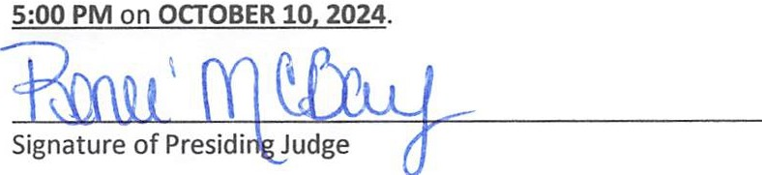At , o'clock M

OCT O 3 2024

