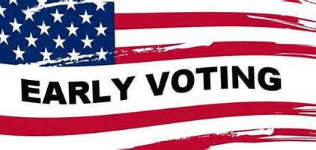
EARLY VOTING INFORMATION…
DATE | POLLS OPEN | POLLS CLOSE
Monday, October 23rd | 8:00 a.m. | 5:00 p.m.
Tuesday, October 24th | 8:00 a.m. | 5:00 p.m.
Wednesday, October 25th | 8:00 a.m. | 5:00 p.m.
Thursday, October 26th | 8:00 a.m. | 5:00 p.m.
Friday, October 27th | 8:00 a.m. | 5:00 p.m.
SATURDAY, OCTOBER 28th … Polls closed
SUNDAY, OCTOBER 29th … Polls closed
Monday, October 30th | 8:00 a.m. | 5:00 p.m.
Tuesday, October 31st | 8:00 a.m. | 5:00 p.m.
Wednesday, November 1st | 8:00 a.m. | 5:00 p.m.
Thursday, November 2nd | 7:00 a.m. | 7:00 p.m.
Friday, November 3rd | 7:00 a.m. | 7:00 p.m.

