AGENDA
TRINITY COUNTY COMMISSIONERS’ COURT

Regular Session

June 14, 2022

Addendum to Agenda

The Trinity County Commissioners’ Court will meet on Tuesday, June 14, 2022 at 9:00 A.M. in the Commissioners’ Courtroom, at 162 W. First Street, Trinity County Courthouse, Groveton, Texas 75845. The following will be considered:

ADD:

- Discuss and Act on Paying Out Excess Time to Sheriff’s Office Employees Due to Them Not Being Able to Take Time Off

- Recess or Adjourn

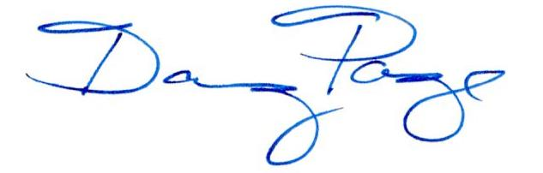

Doug Page, County Judge

CERTIFICATE
I certify that the above notice was posted on the bulletin board located at the Trinity County Courthouse, 162 W. First Street, Groveton, Texas 75845 (1st Floor – Elevator Vestibule) and on the Worldwide Web at www.co.trinity.tx.us, on the __ day of _____________, 2022 at o’clock .

Shasta Bergman, County Clerk

