NOTICE OF PUBLIC HEARING
The Falls County Commissioners Court will conduct a public hearing at its regularly scheduled meeting, on June 27, 2022, at 9:00 a.m. to consider and to act upon Resolutions to (1) confirm that Falls County, Texas, is eligible to participate in tax abatement; (2) consider the request of Texas Pneumatic Tools, Inc. to designate a certain area of Falls County, Texas, (described and depicted below) as a Reinvestment Zone for Tax Abatement to be known as the Falls County Reinvestment Zone - Texas Pneumatic Tools, Inc, establishing the boundaries thereof, and providing for an effective date; and (3) consider accepting and approving a Tax Abatement Agreement between Falls County and Texas Pneumatic Tools, Inc., pursuant to the provisions of the Property Redevelopment and Tax Abatement Act, Chapter 312 of the Texas Tax Code.

The Application for Tax Abatement is made by Texas Pneumatic Tools, Inc. and the property is identified below:
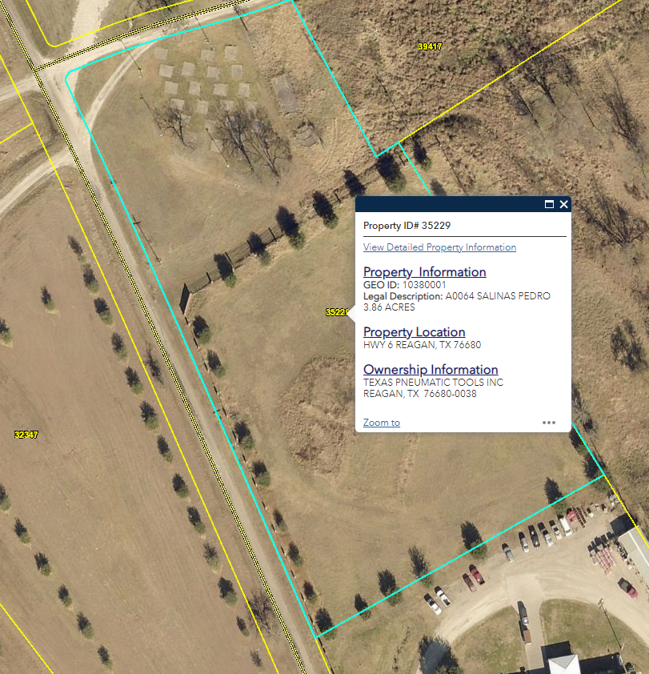
Pursuant to the terms of the Falls County Reinvestment Zone, improvements consisting of a new 25,000 square-foot manufacturing building (distribution center) will be constructed, erected, or placed on the property within the zone will be eligible to receive manufacturing facility tax abatement. The estimated costs of the improvements is $900,000.00.

In determining whether to designate the Reinvestment Zone, the Falls County Commissioners Court will consider whether the Falls County Reinvestment Zone described meets the criteria set forth in Texas Tax Code §312.202 for the creation of a reinvestment zone as set forth in the Property Redevelopment and Tax Abatement Act, as amended, In determining whether to accept and approve the Tax Abatement Agreement between Falls County and Texas Pneumatic Tools, Inc., the Falls County Commissioners Court will consider the proposed Tax Abatement Agreement in light of the criteria in the Falls County Guidelines and Criteria, as in effect or as may be adopted at the public hearing.

All interested persons may appear and present testimony and evidence regarding the designation of the Reinvestment Zone and approval of the Tax Abatement Agreement. The public hearing will take place at 9:00 a.m. on June 27, 2022, in the Commissioner’s Courtroom, Falls County Courthouse, 125 Bridge Street, Marlin, Texas 76661.

