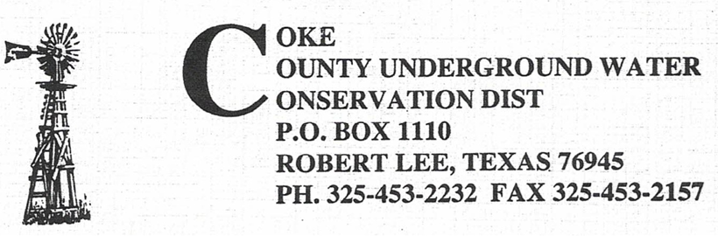

Scheduled Board Meetings 2025-2026
November 11, 2025
January 13, 2026
March 10, 2026
May 12, 2026
July 7, 2026
September 8, 2026

Called Meetings may be scheduled at any time with a required posting of three business days prior. Please check Coke County Clerk’s Office for additional postings.

